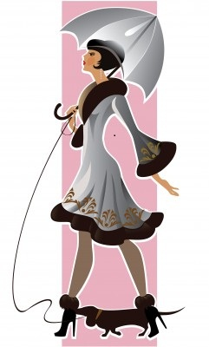

**Mutt Strut on Main**

**When:** Saturday, October 1, 2011

10:00 a.m. – 2:00 p.m.

**Where:** Main Plaza

Boerne’s historic downtown

**Why:** The Mutt Strut on Main seeks to raise $20,000 for

the drilling of two water wells in Uganda.

**What:** Dog Parade down historic Boerne

Dog Fashion Show

Dog Agility Show

Food Music Bouncing Inflatables

All dogs are encouraged to come in costume!

**From One Child to Another®**

**FromOneChild.org**

Why: The Mutt Strut on Main seeks to raise

$20,000 for the drilling of two water wells

in Uganda.

Why: The Mutt Strut on Main seeks to raise

$20,000 for the drilling of two water wells

in Uganda.

What: Dog Parade down historic Boerne’s Main Street.

Dog Fashion Show

Dog Agility Show

Food, Music, Bouncy Inflatables, and fun!

All dogs are encouraged to come in costume.

**www.leadmeinternational.org**

Why: The Mutt Strut on Main seeks to raise

$20,000 for the drilling of two water wells

in Uganda.

What: Dog Parade down historic Boerne’s Main Street.

Dog Fashion Show

Dog Agility Show

Food, Music, Bouncy Inflatables, and fun!

All dogs are encouraged to come in costume.

**www.leadmeinternational.org**